Assignments on Data Structure #3

Trees and Graphs

## Problem 1

You need to create a virtual Command Prompt (VCP) for managing virtual directories where a few operations/commands will be supported.

Proper messages should be shown for invalid commands and error during command execution. E.g. *command does not exist*, *directory already exists* etc.

Initially there should be a Root directory as the present working directory. Let’s say ***R:***

Present working directory indicator should be shown during the prompt. E.g. ***R:\new\programs>***

| Command | Description | Example |
| --- | --- | --- |
| mkdir | Create a new directory | mkdir New |
| cd | Change Directories | cd New |
| bk | Move to parent directory | back |
| ls | Display list of all folders in the current folder along with their date-time of creation. It also displays total subfolders (1st level only) present in the current directory. | list New |
| find | Find a folder in current or subfolders (recursively). | find New |
| tree | To display the complete directory structure | tree |
| exit | Exit the VCP | exit |

**Note** - Folders are not be actually created in the file system

For *tree* command use **\u2514**, **\u251c**, **\u2500** and **\u2502** unicode symbols.



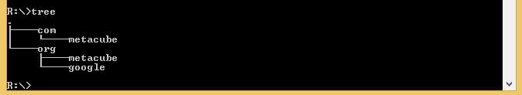

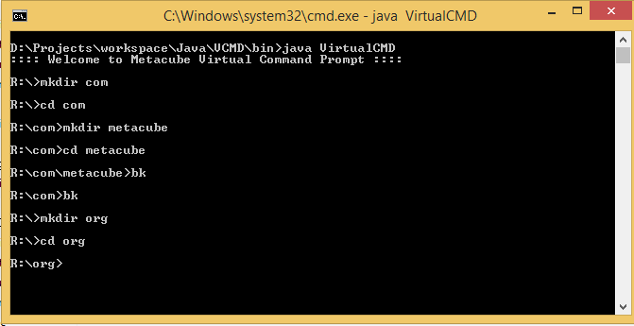

## Problem 2

Define the interface for priority queue, and implement it using an array.

## Problem 3

Your cricket team is playing against Virat Kohli and you being the captain want Virat to score as low as possible. You know his strategy is to score max runs of the bowler who has minimum balls left to bowl. For instance if there are 2 bowlers with 5 and 7 balls left to bowl respectively then Virat will score max on bowler 1 than bowler 2. As an input you need to provide the total number of bowlers, the total number of balls Virat is going to play and the quota of each bowler. You need to tell the order of the bowler chosen by you as captain.

**Note:** There isn't any concept of 'Over' and none of the bowlers can get Virat out.